**Customer Service Requests Analysis Project**

# **Understand the dataset**:

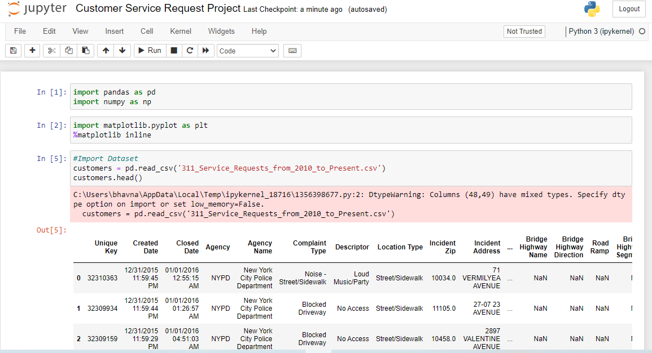

## Import Dataset

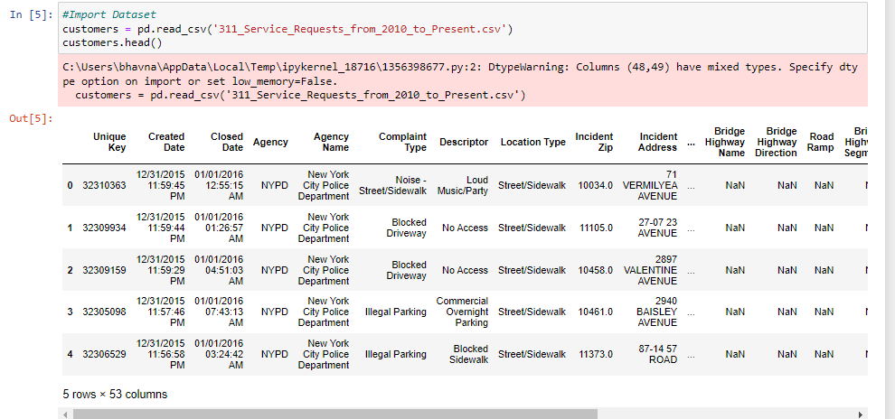

## visualize the dataset

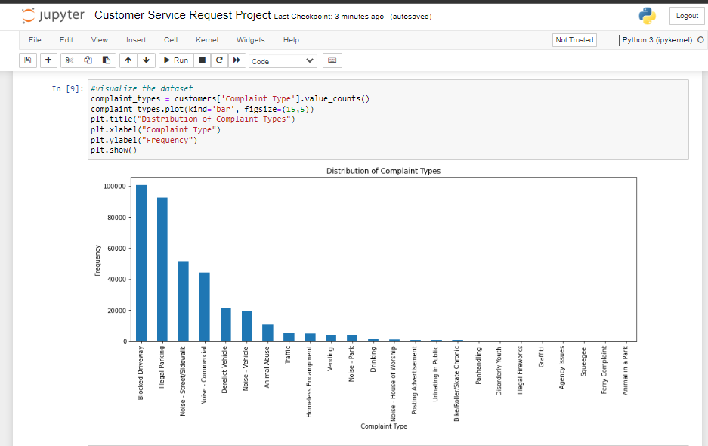

## Print the columns of the DataFrame Identify the shape of the dataset

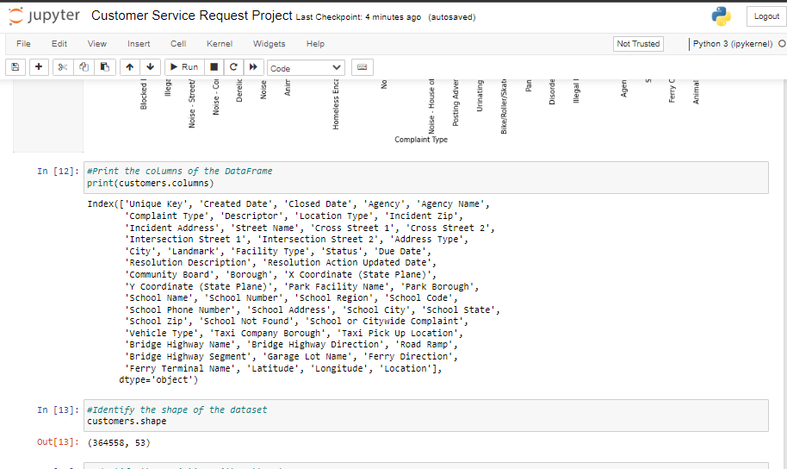

## Identify the variables with null values

## 

# . **Perform basic data exploratory analysis:**

## Draw a frequency plot to show the number of null values in each column of the DataFrame

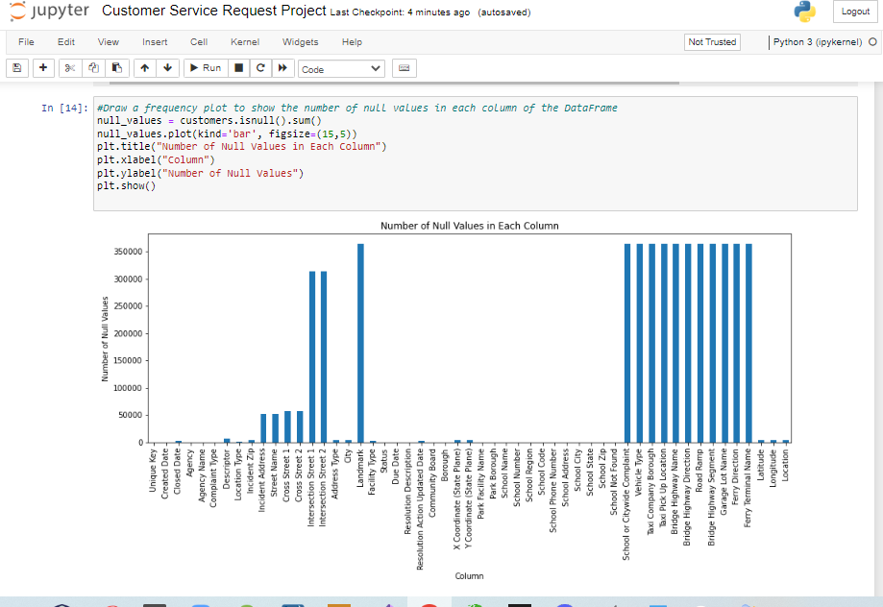

## Remove the records whose Closed Date values are null

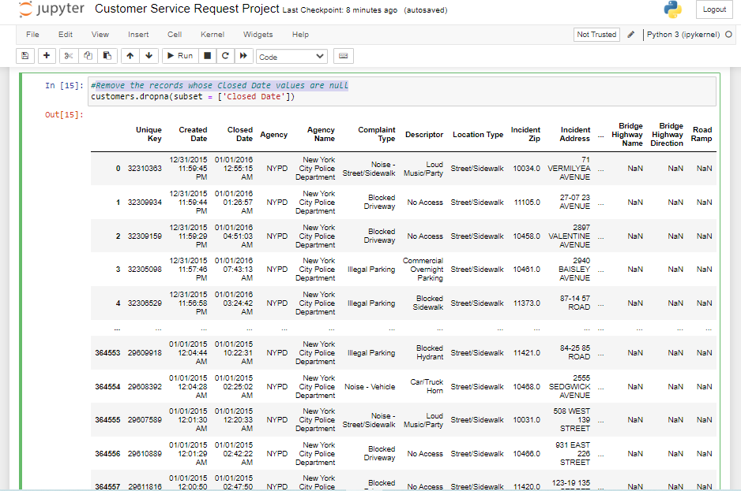

## Calculate the time elapsed in closed and creation date

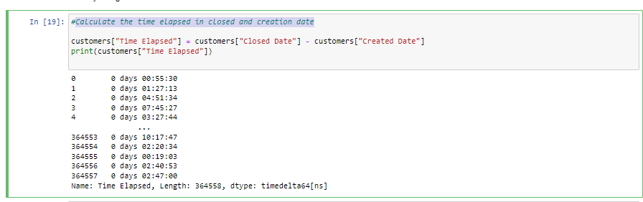

## Convert the calculated date to seconds to get a better representation

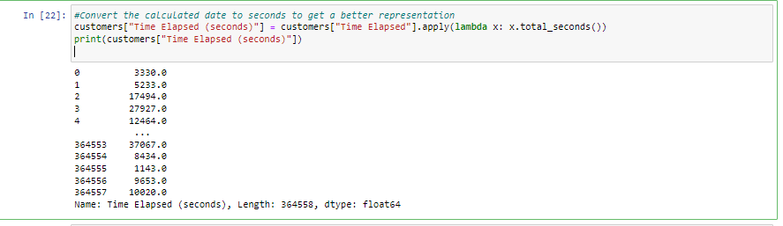

## View the descriptive statistics for the newly created column

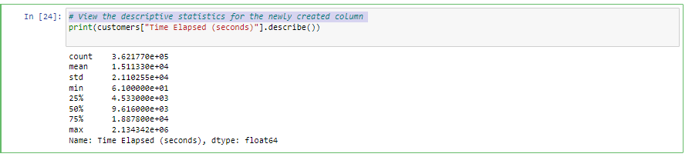

## Check the number of null values in the Complaint_Type and City columns

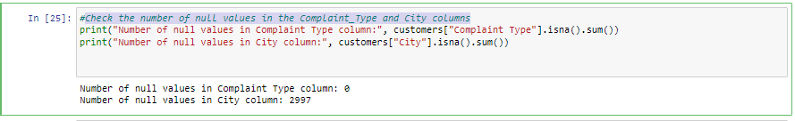

## Impute the NA value with Unknown City

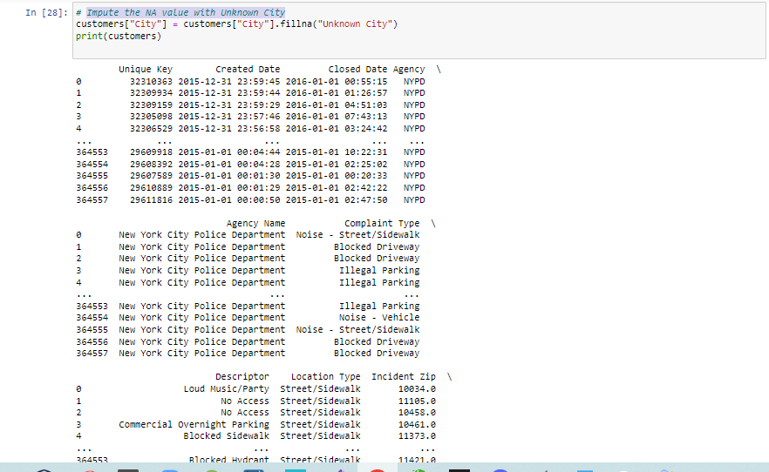

## Draw a frequency plot for the complaints in each city

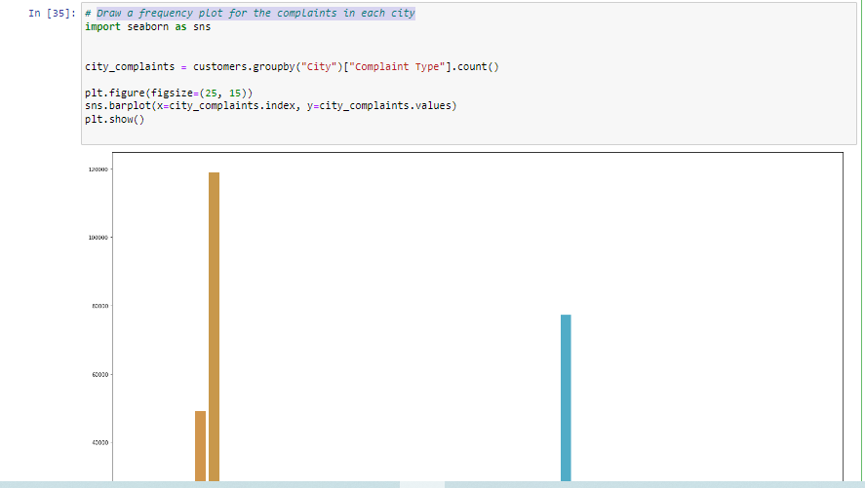

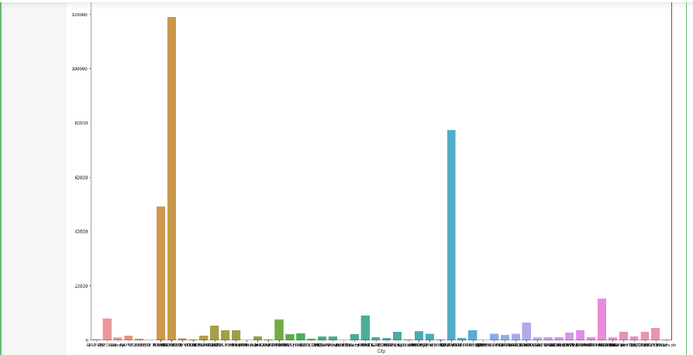

## Create a scatter and hexbin plot of the concentration of complaints across Brooklyn

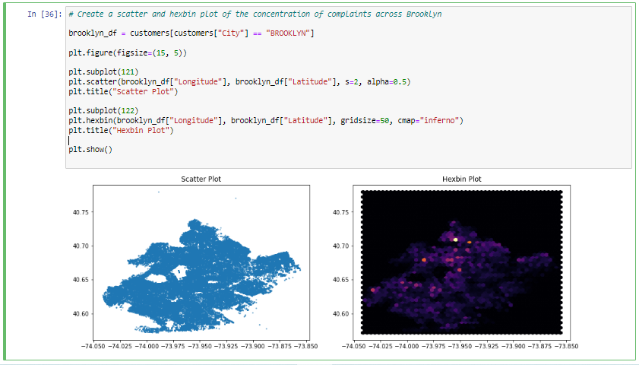

# **Find major types of complaints**:

## Plot a bar graph to show the types of complaints

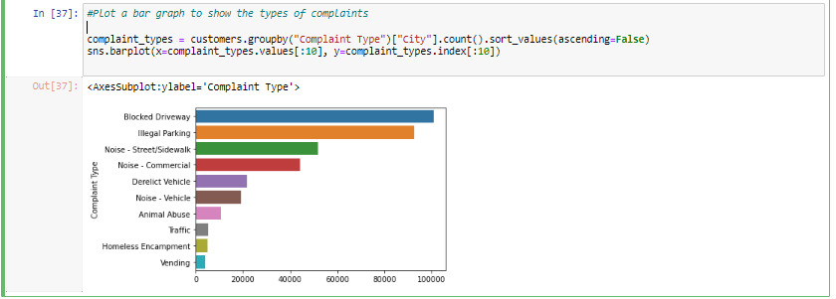

## Check the frequency of various types of complaints for New York City

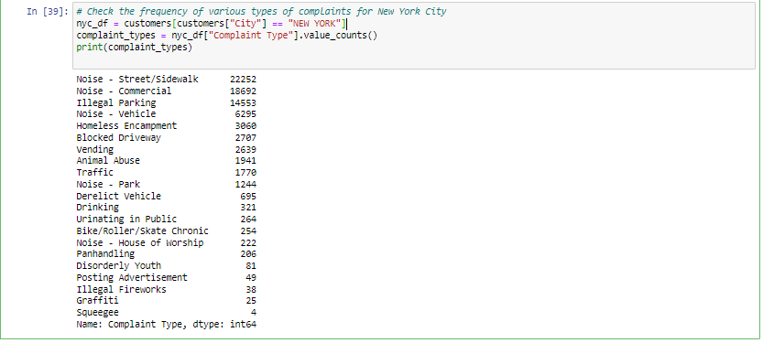

## Find the top 10 complaint types

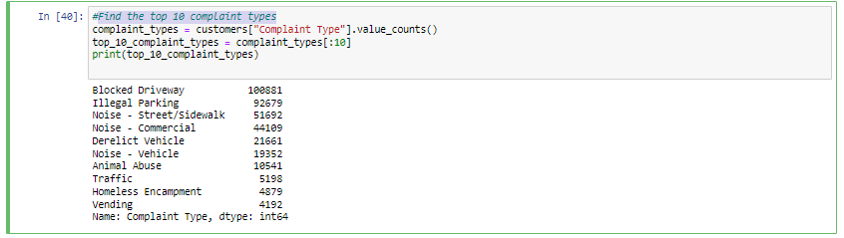

## Display the various types of complaints in each city

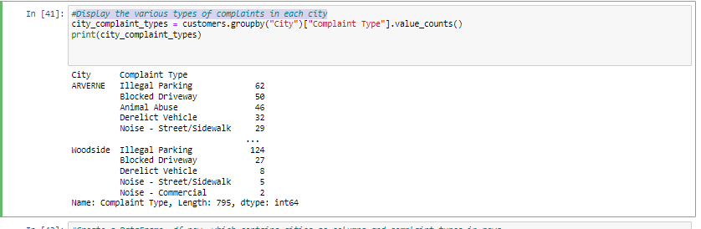

## Create a DataFrame, df_new, which contains cities as columns and complaint types in rows

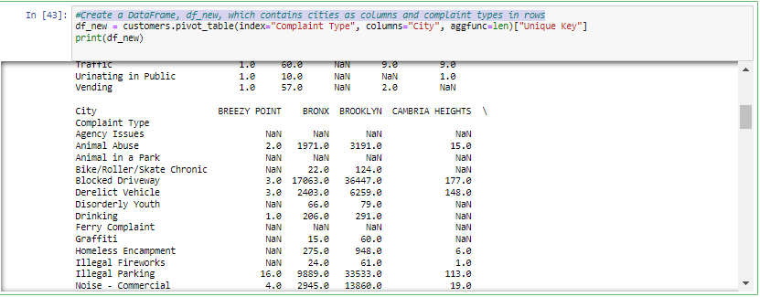

# **Visualize the major types of complaints in each city**

## Draw another chart that shows the types of complaints in each city in a single chart, where different colors show the different types of complaints

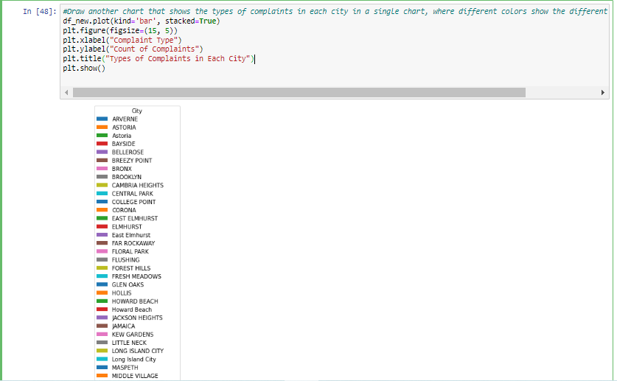

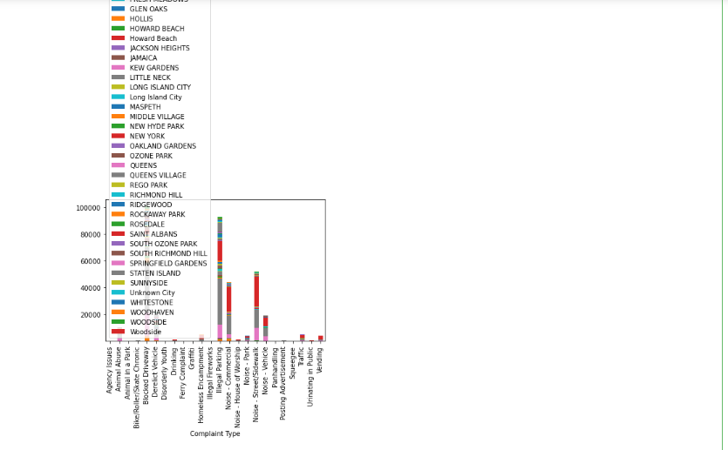

## Sort the complaint types based on the average Request_Closing_Time grouping them for different locations

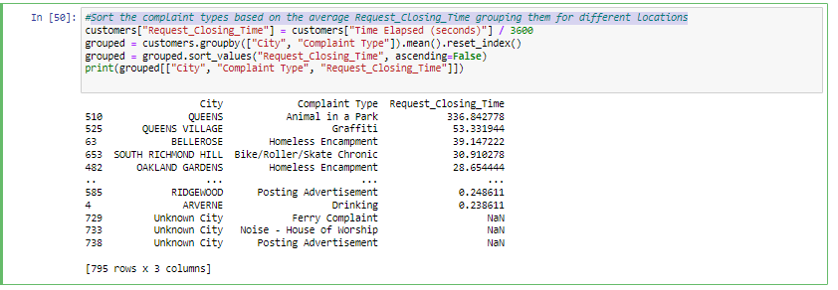

# **See whether the average response time across different complaint types is similar (overall)**

## Visualize the average of Request_Closing_Time Identify the significant variables by performing statistical analysis using p-values

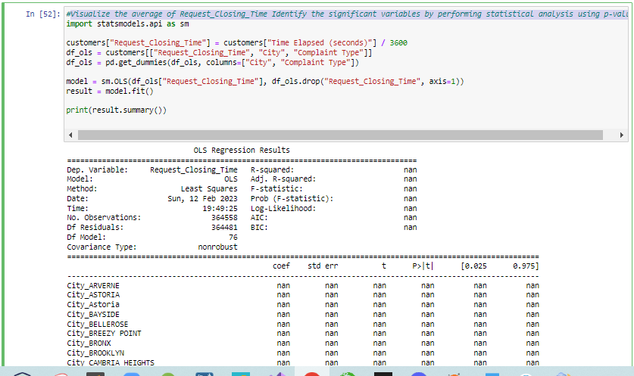

# **Perform a Kruskal-Wallis H test**



 